Whole Numbers Set
# Source: AI Source: Provided by: [Data Path: Persons Table -> ID Column: 1, Name_En Column: Motasem Essam] -> From: [ChatGPT] on [7/15/2026]
The Whole Numbers Set is the set of non-negative integers, consisting of zero and all positive counting numbers. It extends the Natural Numbers Set by including 0, making it suitable for representing quantities that may have no objects.
Whole numbers are fundamental to arithmetic, algebra, number theory, computer science, engineering, statistics, and many everyday applications.

Definition
# Source: AI Source: Provided by: [Data Path: Persons Table -> ID Column: 1, Name_En Column: Motasem Essam] -> From: [ChatGPT] on [7/15/2026]
The Whole Numbers Set is the collection of all non-negative integers.
It is commonly denoted by
$$\boxed{W}$$
(or sometimes $W$, although $W$is more common in school mathematics).
The set is defined as
$$\boxed{W=\{0,1,2,3,4,5,…\}}$$
The ellipsis ($…$) indicates that the set continues infinitely.

Set Notation
# Source: AI Source: Provided by: [Data Path: Persons Table -> ID Column: 1, Name_En Column: Motasem Essam] -> From: [ChatGPT] on [7/15/2026]
Roster Notation
$$W=\{0,1,2,3,4,5,…\}$$
Set-Builder Notation
$$\boxed{W=\{ x∈Z∣x≥0 \}}$$
This means:
"The set of all integers greater than or equal to zero."

Examples
# Source: AI Source: Provided by: [Data Path: Persons Table -> ID Column: 1, Name_En Column: Motasem Essam] -> From: [ChatGPT] on [7/15/2026]
Whole numbers include
$$0, 1, 2, 5, 10, 50, 100, 1000$$

Non-Examples
# Source: AI Source: Provided by: [Data Path: Persons Table -> ID Column: 1, Name_En Column: Motasem Essam] -> From: [ChatGPT] on [7/15/2026]
The following are not whole numbers:
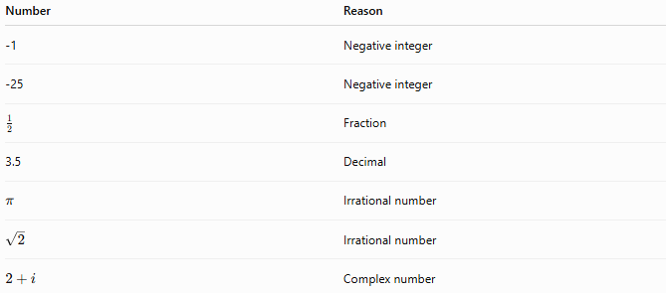
Number | Reason
-1 | Negative integer
-25 | Negative integer
$$\frac{1}{2}$$ | Fraction
3.5 | Decimal
$$π$$ | Irrational number
$$\sqrt{2}$$ | Irrational number
$$2+i$$ | Complex number

Characteristics
# Source: AI Source: Provided by: [Data Path: Persons Table -> ID Column: 1, Name_En Column: Motasem Essam] -> From: [ChatGPT] on [7/15/2026]
Whole numbers are:
- Non-negative
- Integers
- Countable
- Ordered
- Infinite in quantity
- Discrete (no values between consecutive whole numbers)

Properties
# Source: AI Source: Provided by: [Data Path: Persons Table -> ID Column: 1, Name_En Column: Motasem Essam] -> From: [ChatGPT] on [7/15/2026]
Whole numbers satisfy the following properties.
Closure
Closed under:
- Addition
$$4+7=11$$
- Multiplication
$$6×5=30$$
Not closed under:
- Subtraction
$$3-7=-4$$
- Division
$$5÷2=2.5$$

Commutative Property
Addition
$$a+b=b+a$$
Multiplication
$$ab=ba$$

Associative Property
Addition
$$\left(a+b)+c=a+(b+c\right)$$
Multiplication
$$\left(ab)c=a(bc\right)$$

Distributive Property
$$a(b+c)=ab+ac$$

Identity Elements
Additive Identity
$$\boxed{a+0=a}$$
The number 0 is the additive identity.

Multiplicative Identity
$$\boxed{a×1=a}$$
The number 1 is the multiplicative identity.

Ordering
Whole numbers are arranged in increasing order:
$$0<1<2<3<4<5<⋯$$

Successor
Every whole number has exactly one successor.
If
$$n∈W,$$
then
$$\boxed{\text{Successor}=n+1}$$
Examples:
- Successor of 0 is 1.
- Successor of 25 is 26.

Predecessor
Every whole number except 0 has a predecessor.
Examples:
- Predecessor of 8 is 7.
- Predecessor of 100 is 99.
The number 0 has no predecessor within the set of whole numbers.

Cardinality
The Whole Numbers Set is infinite.
Its cardinality is
$$\boxed{ℵ_{0}}$$
which means it is countably infinite.

Relationship to Other Number Sets
# Source: AI Source: Provided by: [Data Path: Persons Table -> ID Column: 1, Name_En Column: Motasem Essam] -> From: [ChatGPT] on [7/15/2026]
$$\boxed{N⊂W⊂Z⊂Q⊂R⊂C}$$
Every whole number is also:
- an integer,
- a rational number,
- a real number,
- and a complex number (with imaginary part equal to zero).

Examples
# Source: AI Source: Provided by: [Data Path: Persons Table -> ID Column: 1, Name_En Column: Motasem Essam] -> From: [ChatGPT] on [7/15/2026]
Example 1
Determine whether
$$45$$
is a whole number.
Yes.
$$45∈W$$

Example 2
Determine whether
$$0$$
is a whole number.
Yes.
$$0∈W$$

Example 3
Determine whether
$$-8$$
is a whole number.
No.
Negative numbers are not whole numbers.

Example 4
Determine whether
$$\frac{5}{2}$$
is a whole number.
No.
Fractions are not whole numbers.

Example 5
Is there a largest whole number?
No.
For every whole number
$$n,$$
there exists another whole number
$$n+1.$$

Applications
# Source: AI Source: Provided by: [Data Path: Persons Table -> ID Column: 1, Name_En Column: Motasem Essam] -> From: [ChatGPT] on [7/15/2026]
Whole numbers are used in:
- Counting
- Arithmetic
- Number theory
- Programming
- Computer science
- Inventory management
- Statistics
- Engineering
- Algorithms
- Scientific computing

Real-Life Applications
# Source: AI Source: Provided by: [Data Path: Persons Table -> ID Column: 1, Name_En Column: Motasem Essam] -> From: [ChatGPT] on [7/15/2026]
Whole numbers are used for:
- Counting objects
- Inventory quantities
- Age (in completed years)
- House numbers
- Page numbers
- Seat numbers
- Product quantities
- Scores in many games
- Identification numbers
- Population counts

Common Mistakes
# Source: AI Source: Provided by: [Data Path: Persons Table -> ID Column: 1, Name_En Column: Motasem Essam] -> From: [ChatGPT] on [7/15/2026]
- Confusing whole numbers with natural numbers.
- Assuming negative integers are whole numbers.
- Believing fractions belong to the whole numbers.
- Assuming decimals are whole numbers.
- Forgetting that 0 is included in the Whole Numbers Set.

Key Points
# Source: AI Source: Provided by: [Data Path: Persons Table -> ID Column: 1, Name_En Column: Motasem Essam] -> From: [ChatGPT] on [7/15/2026]
- Whole numbers include 0 and all positive integers.
- They contain no negative numbers.
- They are infinite.
- They are closed under addition and multiplication.
- They extend the Natural Numbers Set by including zero.

Whole Numbers vs. Natural Numbers
# Source: AI Source: Provided by: [Data Path: Persons Table -> ID Column: 1, Name_En Column: Motasem Essam] -> From: [ChatGPT] on [7/15/2026]
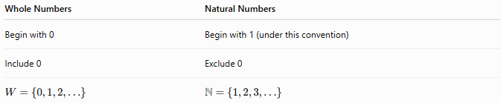
Whole Numbers | Natural Numbers
Begin with 0 | Begin with 1 (under this convention)
Include 0 | Exclude 0
$$W=\{0,1,2,…\}$$ | $$N=\{1,2,3,…\}$$

Whole Numbers vs. Integers
# Source: AI Source: Provided by: [Data Path: Persons Table -> ID Column: 1, Name_En Column: Motasem Essam] -> From: [ChatGPT] on [7/15/2026]
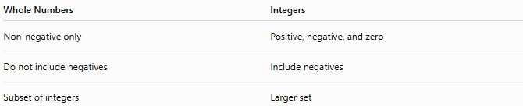
Whole Numbers | Integers
Non-negative only | Positive, negative, and zero
Do not include negatives | Include negatives
Subset of integers | Larger set

Whole Numbers vs. Rational Numbers
# Source: AI Source: Provided by: [Data Path: Persons Table -> ID Column: 1, Name_En Column: Motasem Essam] -> From: [ChatGPT] on [7/15/2026]
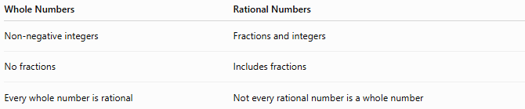
Whole Numbers | Rational Numbers
Non-negative integers | Fractions and integers
No fractions | Includes fractions
Every whole number is rational | Not every rational number is a whole number

Conclusion
# Source: AI Source: Provided by: [Data Path: Persons Table -> ID Column: 1, Name_En Column: Motasem Essam] -> From: [ChatGPT] on [7/15/2026]
The Whole Numbers Set, denoted by $W$, is the set of all non-negative integers
$$W=\{0,1,2,3,4,…\}.$$
It extends the Natural Numbers Set by including 0, making it suitable for representing quantities that may be absent as well as quantities that can be counted. Whole numbers are infinite, ordered, discrete, and closed under addition and multiplication, providing one of the fundamental building blocks for arithmetic, algebra, and all higher branches of mathematics.

